# **Project- Case Study on Twitter**

**Problem Statement**

# **Case Study on twitter to explain the concept of schema design and**

# **Relationship Between Entities in Relational Databases.**

**Product Dissection for Twitter**

**Company Overview:**

Twitter, established in 2006 by Jack Dorsey, Biz Stone, and Evan Williams, has revolutionised real-time communication globally, reshaping the way individuals connect, share information, and engage in public discourse. As a prominent player in the social media realm, Twitter's platform enables users to express thoughts, follow trends, and engage in dynamic conversations across the world. Acquired and expanded over the years, Twitter's succinct format and impactful functionality have made it an influential presence in the digital and social networking sphere, attracting diverse users worldwide and solidifying its position as a primary medium for timely, interactive engagement.

**Product Dissection and Real-World Problems Solved by Twitter:**

Twitter, as a significant force in the realm of social media, has adeptly resolved critical real-world challenges through its innovative and groundbreaking product functionalities. With a distinctive focus on real-time communication and the concise expression of thoughts, Twitter effectively reconnects users with authentic engagement and public discourse. By allowing users to share succinct, engaging posts, Twitter provides an effective solution to the need for immediate, concise expression and interaction, thus fostering genuine connections and enabling users to participate in global conversations that transcend traditional boundaries.

Twitter's impactful functionality, including likes, retweets, and trending topics, has revolutionised the manner in which users interact with content and current events. Addressing the challenge of information overload, Twitter streamlines relevant content delivery, facilitating the discovery of news, trends, and diverse perspectives tailored to individual interests. Furthermore, Twitter's use of hashtags has transformed content discoverability by enabling users to categorise and follow conversations on specific topics, successfully overcoming the obstacle of navigating through a wealth of information to find pertinent content and actively engage in meaningful discussions.

In summary, Twitter's product design has effectively tackled real-world challenges by creating a platform that facilitates immediate, impactful interaction, while fostering connections and offering a space for genuine expression. Through its diverse features, Twitter addresses the need for real-time engagement, content curation, and informational discovery, thereby influencing the digital landscape and providing pragmatic solutions to the evolving needs of its diverse global user base.

**Case Study: Real-World Problems and Twitter's Innovative Solutions**

Twitter, a prominent and influential social media platform, has not only redefined the landscape of real-time communication and information sharing, but has also effectively tackled substantial real-world challenges through its cutting-edge features. By keenly observing user requirements and harnessing technological advancements, Twitter has established itself as a solution-centric platform that facilitates global conversations, promotes succinct expression, and enriches digital discourse and interaction.

**Problem 1: Disconnect in Digital Relationships**

**Real-World Challenge:** As our digital interactions increase, the inability to foster genuine connections remains a prevalent concern. Users often find it challenging to convey emotions and engage meaningfully through brief written communication, thereby contributing to a sense of detachment in digital relationships.

**Twitter's Solution**:

Recognizing the need for authentic and immediate interactions, Twitter strives to bridge the emotional gap in digital relationships. By providing a platform for succinct yet impactful expression, users can engage in real-time conversations, share thoughts, and participate in global discourse. The power of concise and immediate communication on Twitter acts as a bridge, enabling users to establish genuine connections and facilitate meaningful conversations. Through this approach, Twitter effectively addresses the challenge of detachment in digital relationships, fostering authentic engagement and promoting real-time interactions.

**Problem 2: Information Overload**

Real-World Challenge: Prior to Twitter, gaining access to real-time and diverse conversations across various topics was challenging, as traditional media and communication channels provided limited avenues for direct, immediate interaction and information sharing.

**Twitter's Solution:**

Twitter tackles the challenge of information overload through its "Trending Topics" feature and timeline curation. Using powerful algorithms, the platform identifies and presents trending conversations, hashtags, and topics personalized to each user's interests. By doing so, Twitter offers users a mechanism to engage with relevant, current, and personalized content, thereby addressing the issue of information overload and enhancing the user experience.

**Problem 3: Finding a Niche for Creativity**

**Real-World Challenge:** Numerous individuals seek an avenue to exhibit their creativity and potentially monetize their talents, yet identifying an appropriate platform for showcasing their skills remains a significant hurdle.

**Twitter's Solution:**

Twitter provides a platform where creatives can exhibit their talents, gain a following, and engage with diverse audiences, effectively fostering an environment for collaboration and creativity. Through features such as visual tweets, polls, and real-time engagement, Twitter enables content creators to showcase their talents while facilitating networking opportunities and potential career advancement, thereby addressing the challenge of finding an ideal space for creative expression and professional development.

**Problem 4: Limited Personal Branding**

**Real-World Challenge:** Creating and expressing a distinctive online identity faces constraints on traditional text-based platforms, hindering comprehensive personal branding efforts.

**Twitter's Solution:**

Twitter addresses the challenge of limited personal branding by providing diverse elements for user profiles, including a profile picture, bio, header image, and pinned tweets. These components enable users to visually and succinctly convey their personality, interests, and professional endeavours, allowing for a more expansive and compelling approach to personal branding that aligns with modern online trends.

**Conclusion:**

Twitter's evolution from a microblogging platform to a global hub illustrates its remarkable capacity to identify real-world challenges and deliver inventive solutions. By facilitating authentic interactions, curating dynamic content, championing creativity, and enabling comprehensive personal branding, Twitter has effectively tackled a multitude of obstacles prevalent in the digital sphere. This case study illustrates how Twitter's user-focused strategies and ongoing advancements have firmly established it as a frontrunner in the social media landscape, significantly influencing the dynamics of online engagement and interaction.

**Top Features of Twitter:**

1. **User Profiles:** Twitter allows users to create personalised profiles, showcasing their identity through usernames, full names, bios, and profile pictures. This feature enables individuals to establish a distinct online presence.
2. **Tweets:** At the core of Twitter's functionality is the ability to share concise thoughts and multimedia content, including photos, videos, and links. Users can engage with trending topics, news, and personal updates, fostering diverse forms of expression.
3. **Interactions:** Central to Twitter's platform is the engagement it encourages. Users can express interest by liking tweets, share responses through comments, or retweet valuable content to their followers, effectively boosting discoverability.
4. **Followers and Following:** Twitter's "Follow" feature facilitates connections, allowing users to subscribe to accounts of interest and receive their updates directly within their feed. Additionally, users can view their followers and those they follow, fostering transparency and interconnectedness.
5. **Trending Topics:** Twitter propels content discovery through its "Trending Topics" functionality, highlighting discussions, news, and events that are currently popular. This feature promotes the exploration of diverse conversations and fosters a dynamic online experience.
6. **Hashtags:** Twitter is renowned for popularising the use of hashtags, allowing users to categorise their tweets and participate in broader discussions. Incorporating relevant hashtags facilitates wider engagement and interaction, ensuring broader visibility for users' content.

**Schema Description :**

The schema for Twitter comprises various entities that encapsulate diverse dimensions of the platform. These entities include Users, Tweets, Retweets, Likes, Followers, Trending Topics, Hashtags, and more. Each entity possesses specific attributes defining its properties and interconnections with other entities, delineating the intricate structure of the Twitter platform.

**User Entity:**

Users form the backbone of Twitter. The user entity encompasses details pertaining to each user:

* **UserID (Primary Key):** An exclusive identifier assigned to every user.
* **Username:** The selected name that represents the user's account.
* **Email:** The user's email address, serving as a communication channel for account-related interactions.
* **Full_Name:** The complete name of the user, exhibited on their profile.
* **Bio:** A concise narrative space allowing users to articulate themselves and showcase their personality.
* **Registration_Date:** The date marking the user's initiation into the Twitter platform

**Tweet Entity:**

Tweets encapsulate the diverse content shared on the platform:

* **TweetID (Primary Key):** An exclusive identifier assigned to each tweet.
* **UserID (Foreign Key referencing User Entity):** The user responsible for the tweet.
* **Text:** The textual content of the tweet, offering insights and context.
* **Media_URL:** The URL of any associated images, videos, or linked content.
* **Location:** Optional geographic information linked to the tweet.
* **Tweet_Date:** The date when the tweet was posted.

**Reply Entity:**

Replies facilitate user interactions and discussions around tweets:

* **ReplyID (Primary Key):** An exclusive identifier assigned to each reply.
* **TweetID (Foreign Key referencing Tweet Entity):** The tweet associated with the reply.
* **UserID (Foreign Key referencing User Entity):** The user who authored the reply.
* **Text:** The content of the reply.
* **Reply_Date:** The date when the reply was posted.

**Like Entity:**

Likes signify user appreciation for tweets:

* **LikeID (Primary Key):** A unique identifier for each like.
* **TweetID (Foreign Key referencing Tweet Entity):** The tweet being liked.
* **UserID (Foreign Key referencing User Entity):** The user who liked the tweet.
* **Like_Date:** The date when the like was recorded

**Follower Entity:**

Followers establish connections between users:

* **FollowerID (Primary Key):** A unique identifier for each follower relationship.
* **FollowingUserID (Foreign Key referencing User Entity):** The user who is being followed.
* **FollowerUserID (Foreign Key referencing User Entity):** The user who is following.
* **Follow_Date:** The date when the following relationship was initiated.

**Hashtag Entity:**

Hashtags categorise and group content:

* **HashtagID (Primary Key):** A unique identifier for each hashtag.
* **Tag:** The actual text of the hashtag.

**TweetHashtag Entity:**

Associates tweets with hashtags:

* **TweetHashtagID (Primary Key):** A unique identifier for each association.
* **TweetID (Foreign Key referencing Tweet Entity):** The tweet associated with the hashtag.
* **HashtagID (Foreign Key referencing Hashtag Entity):** The hashtag associated with the tweet.

**Relationships in Twitter:**

* **Users post Tweets** – Each user can post multiple tweets.
* **Users reply to Tweet**s – Users can reply to multiple tweets, and each tweet can have multiple replies.
* **Users like Tweets** – Users can like multiple tweets, and each tweet can have multiple likes.
* **Users follow other Users** – Users can follow multiple users and be followed by multiple users.
* **Tweets contain Hashtags** – Tweets can have multiple hashtags, and each hashtag can be associated with multiple tweets.

**ER Diagram:**

We will construct an ER diagram to comprehensively illustrate the relationships and attributes of the entities within the Twitter schema. This ER diagram will provide a visual representation to elucidate the key components of Twitter's data model. By utilising this diagram, you will establish a more comprehensive understanding of the intricate interactions and connections that define the platform's dynamics.

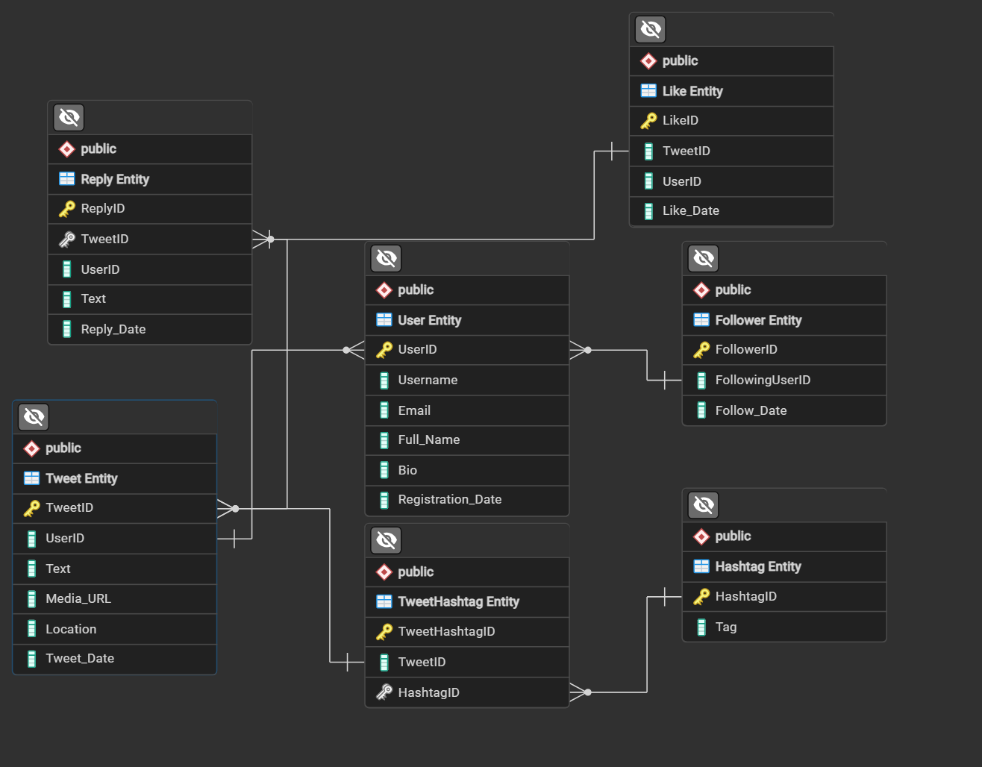

**Conclusion**

In this case study, we explored the design of Twitter's schema and Entity-Relationship diagram. Twitter has transformed online engagement by offering a platform for users to share their thoughts, news, and content with a global community. It has effectively addressed real-world challenges related to communication, information dissemination, personal branding, and trend discovery. Through its inventive features and ongoing advancements, Twitter remains an influential figure in shaping the dynamics of online interaction and content sharing.

.